**Web Application Requirements**

Haoquan Li

Group 11

**Description:**

My web application provides code challenge questions and an online judge, which will test the user’s code for correctness and efficiency by showing how many test cases are passed and the run time of the user’s code.

**Purpose:**

Provide a platform for users to practice solving algorithm and coding problems in job interviews.

**Marketing:**

Posting advertisements on career service websites such as glassdoor.com and monster.com, etc.

**Target Audience:**

Computer science job seekers who want to practice solving interview problems regarding algorithms and coding.

**Competition / Examples:**

www.hackerrank.com and leetcode.com

**Technical Requirements:**

1. Server type: virtual private server
2. Hypervizor: VirtualBox
3. Web Server: Nginx
4. Database: MySQL. (reason: fully-featured RDBM which is easy to work with)
5. Scripting Language: PHP
6. Support Libraries: OpenSSL, PDO, Mbstring, Mcrypt, Tokenizer
7. Framework: Laravel
8. Access to server: SSH
9. Access to database: MySQL user to local MySQL server
10. Security / Authentication: password hashing

**sitemap diagram**

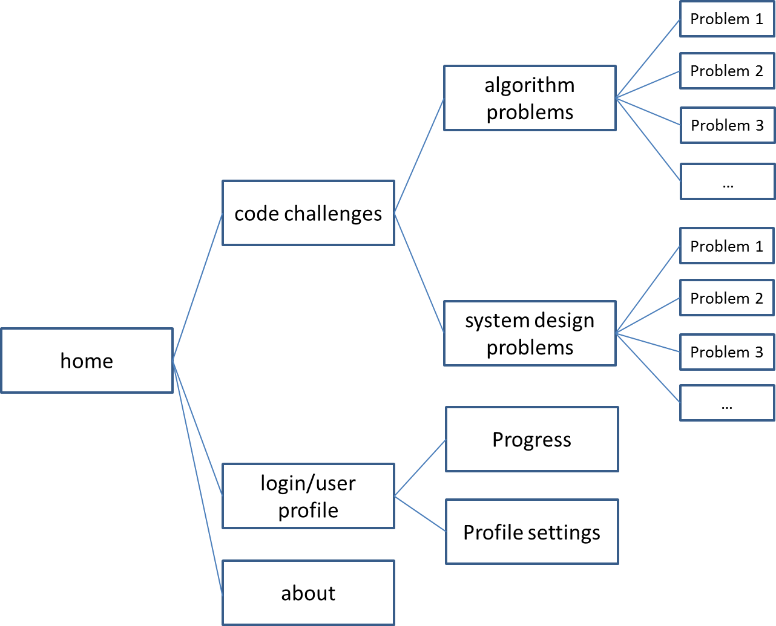

**web app architecture**

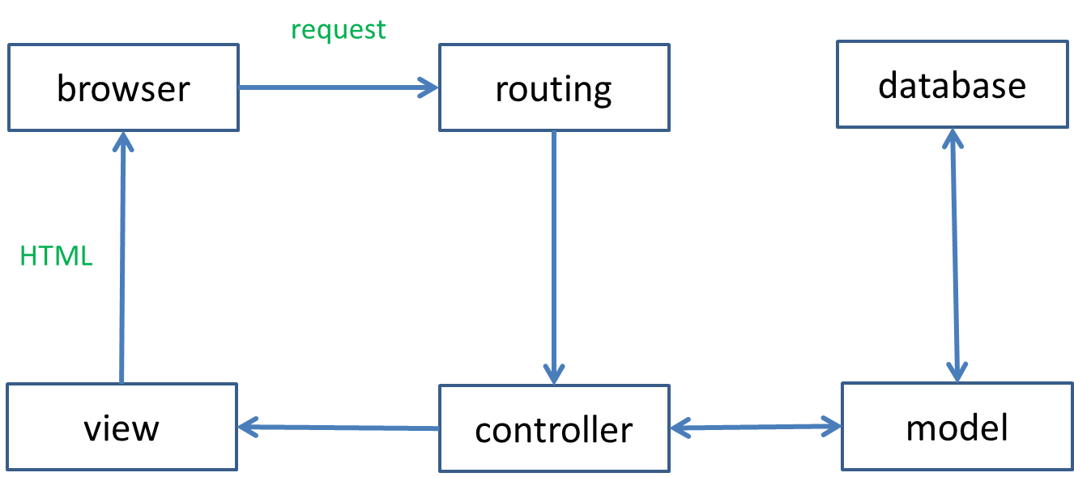

**database diagram**

